In the Studio with Ron Hynes

As a producer it doesn’t get much better. Back in 2002 I got a call from Ron Hynes, one of the best song writers this or any other country has ever produced. He was asking if I’d be interested in working with him on his next album project. Well, that was one of the easiest decisions I’ve ever had to make. It took less than a nanosecond for me to say “Yes!”
That summer we began working on “Get Back Change”. It felt comfortable in part because Ron and I had known each other for many years. We met back in 1973 when I was working as a music producer for CBC Radio and I produced a four-song EP with Ron. We had run across each other occasionally over the years but this was now the first time we had worked together on an entire album project. It was exciting!
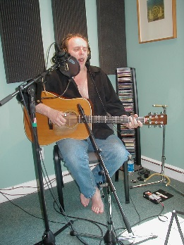
Ron arrived at my home studio in Toronto (The Millstream) with thirteen songs complete and ready to go. I often work with song writers on what we call “song polishing” – making little improvements here and there. I asked Ron if he wanted that kind of input from me but he said, “Nope, these songs are finished.” The confidence of a master craftsman!
We worked on arrangements together and brought in a drummer (Al Cross) and a bassist (David Woodhead) to lay down the basic bed tracks. Once these were done, Ron went back to Newfoundland. I wanted him to stick around as we added the other instruments but he said no, he trusted me. This was most unusual for me because I always work with artists in a collaborative fashion, making sure that they are happy with each thing we add. Not having Ron here for these overdub sessions made me very nervous indeed but Ron insisted. The overdub sessions went ahead without Ron during December of 2002 and January of 2003. We added electric guitar, banjo, keyboards, steel, dobro, and strings. Jenny Whiteley and Sylvia Tyson added some backup vocals and I did rough mixes of everything. I sent the mixes off to Ron and nervously awaited his reaction. A few days later the phone rang and it was Ron. I nervously awaited an angry voice screaming “What have you done to my songs!” but instead I got three words: “I love everything!”. Whew!! Actually there was one guitar lick he wanted changed but that was it.
“Get Back Change” came out during the summer of 2003 and went on to win “Record of the Year” and “Country Record of the Year” at the East Coast Music Awards in 2004!
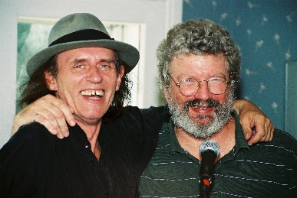
From that auspicious beginning, I was privileged to work with Ron on his next two projects. The self-titled “Ron Hynes” was also an ECMA winner and, among other things, chronicled his victory over drug addiction. The latest record, “Stealing Genius” featured a collection of wonderful new songs inspired by or written with the best of Newfoundland’s authors and poets. With each project, Ron and I have become even better collaborators and closer as friends. He is a total pro in the studio and unswerving in his commitment to the songs and delivering his best possible performance.
So three records down the road, it’s indeed been a privilege to have had the opportunity to work with a singer and song writer of the calibre of Ron Hynes. As I said at the outset, it doesn’t get much better than this.

